Ipad Homework Activity 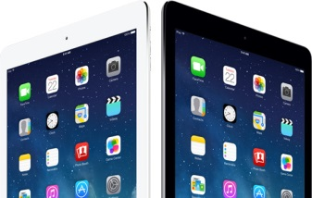
Choose one idea, lesson or app you learned about during the workshop and try it in your classroom during the next two weeks.
What is your choice? How are you going to use it in your class?
________________________________________________________________________________________________________________________________________________________________________________________________________________________________________________________________________________________________________________________________________________________________________________________________________________________________
How did it go? Any questions, things you would change or further information you need.
____________________________________________________________________________________________________________________________________________________________________________________________________________________________________________________________________

